Family-School Partnerships

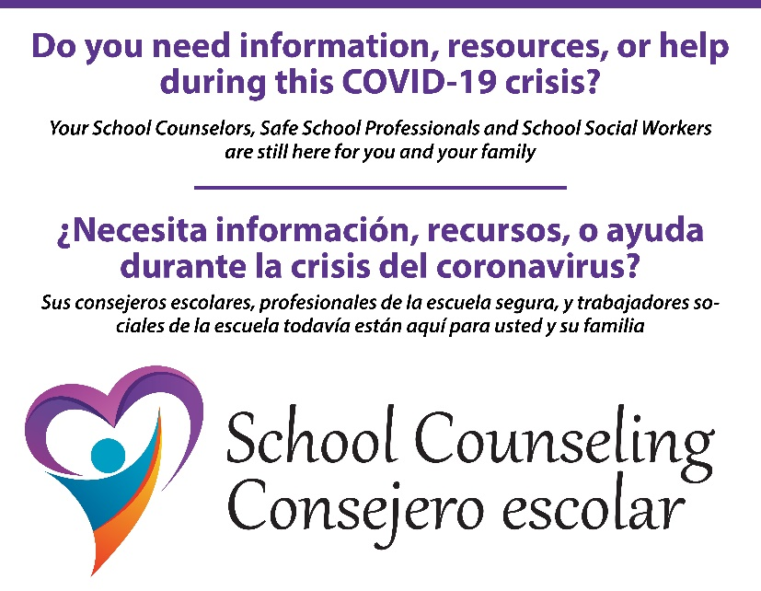

If you have additional questions or need further support related to suicide, child abuse, 504/Home Hospital, staff Psychological First Aid Training, individual student support, family referrals, SafeVoice or Counseling related items please email or call

The Counseling Department at Kloudon@washoeschools.net or 775-721-5284.

https://www.washoeschools.net/Page/375

https://www.washoeschools.net/Page/14625

